Student Name and Number : Sakshi Umesh Teli - 20079303
Course Title : M.Sc. Cyber Security
Lecturer Name: Swati Dongre
Module/Subject Title: Advanced Programming Techniques
Assignment Title: CA_ONE_(30%)
No of Words:

Table of Contents
- Introduction
- Part I: C# Programming
2.1 Question 1 – Contact Book
2.2 Question 2 – File Extension System
- Part II: Python Programming
3.1 Question 3 – Client–Server Application
3.2 Question 4 – Web Scraping and CSV Handling
- Conclusion
- Reference

1.Introduction
I had to use Python and C# to create four different programs for this assignment . I made a file extension information system and a contact book in the C# section . In the Python section , I created a program that scrapes hotel room rates and saves them in CSV file, as well as a client-server application for student admissions. I was able to practice programming , data structure , database , and real-world problem-solving skills through these assignments.

2.Part I: C# Programming
2.1 Question 1 – Contact Book
For this task , I created a contact book program in C# . I made two files for this project :
a) Program.cs for the main menu and all functions.
b) ContactBook.cs for the ContactBook class.
I stored each person’s name, company, phone number, email, and birthdate in the ContactBook class. When the program starts, it automatically adds 20 contacts, and I used an array in the main program to keep all of them. I made a menu that lets the user add, view, update, or delete a contact. I also added a check to make sure the mobile number is a valid 9-digit number. I used basic OOP concepts like classes, objects, properties, and methods. I tested the program using dotnet run, and it keeps running in a loop until the user exits.
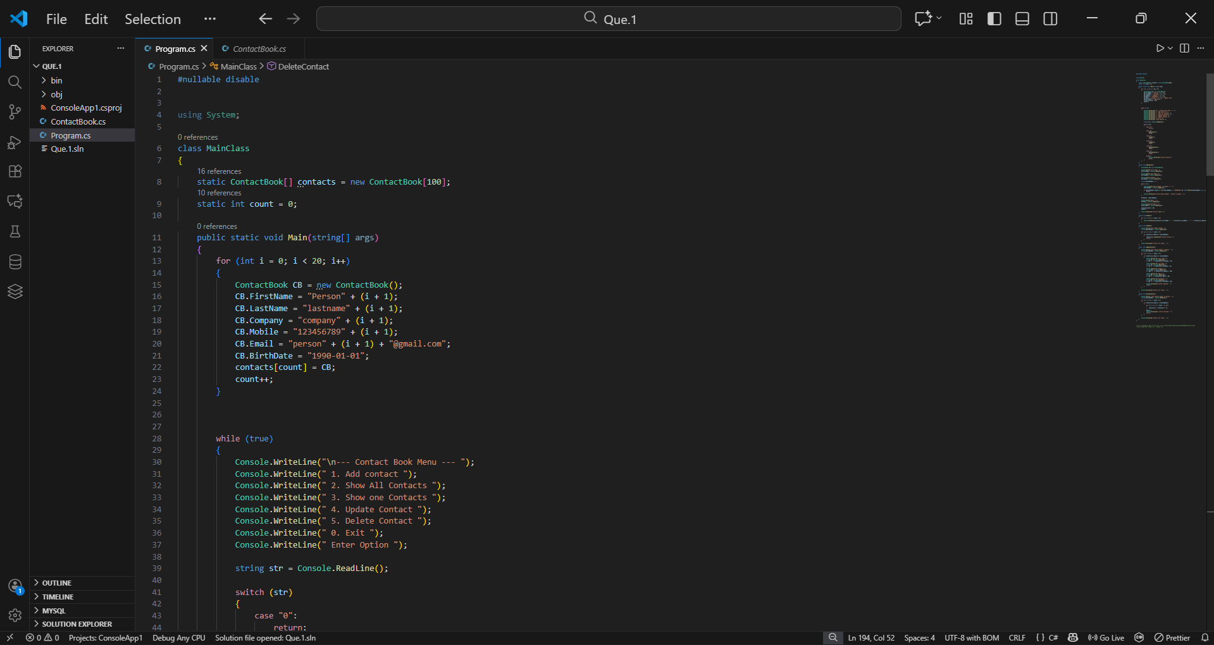
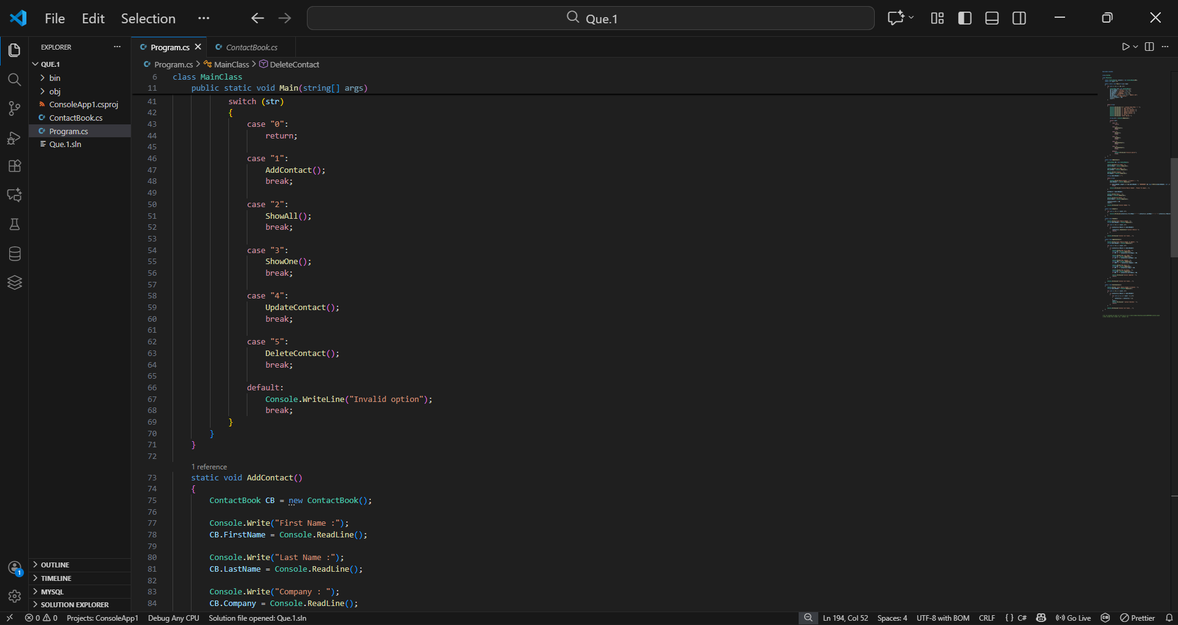
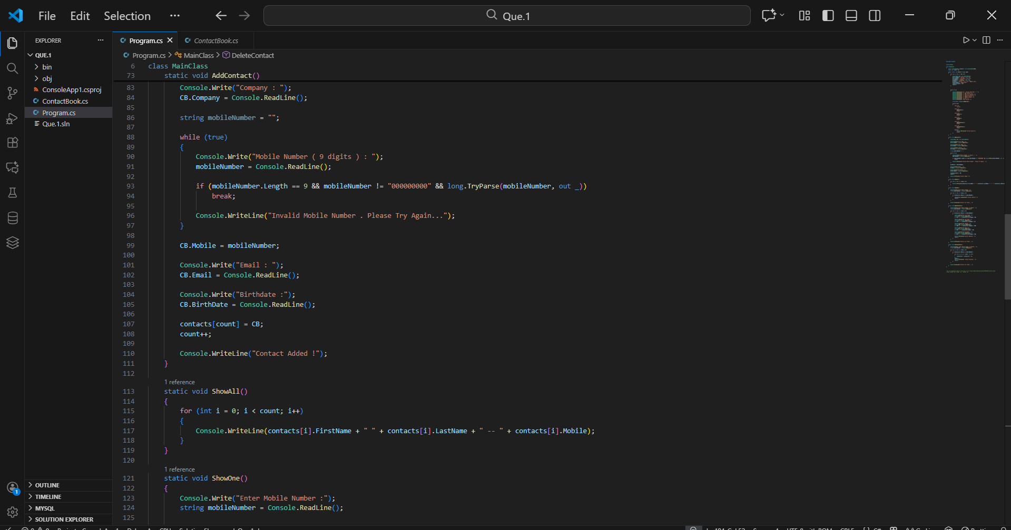
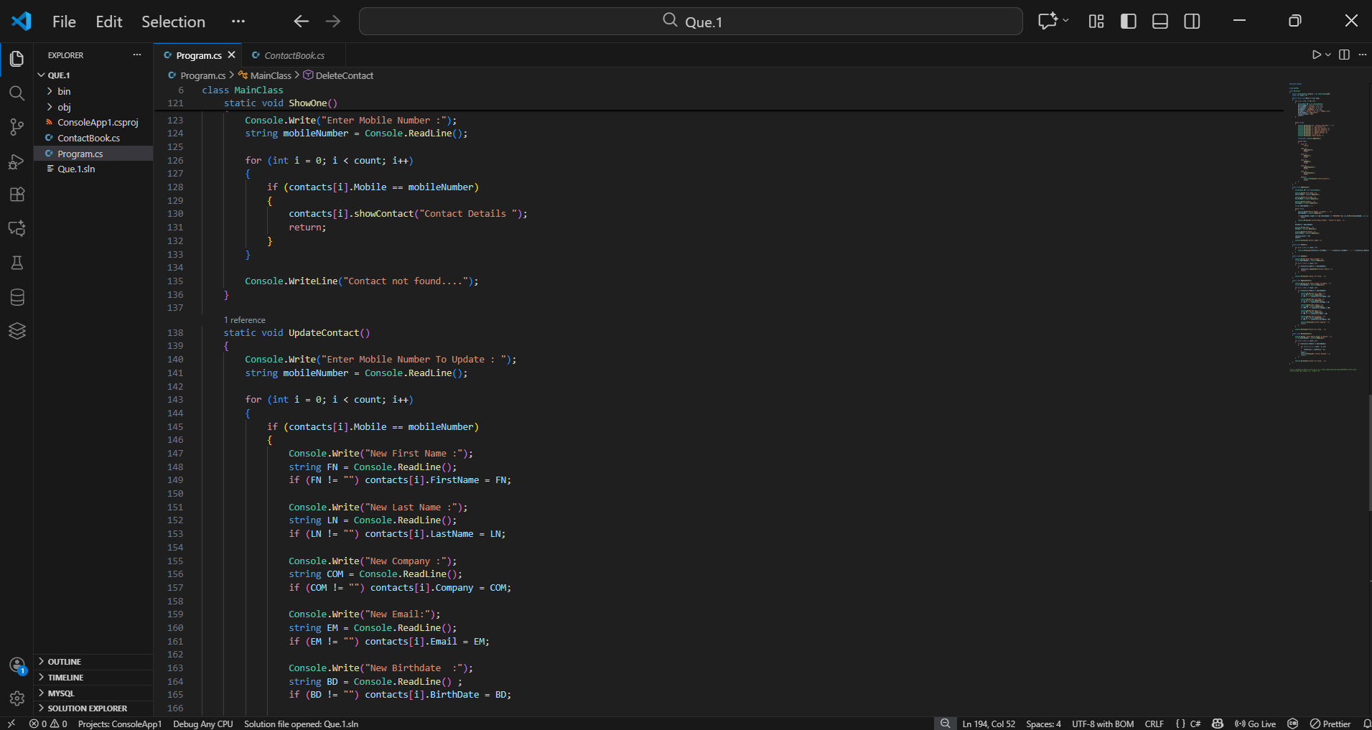
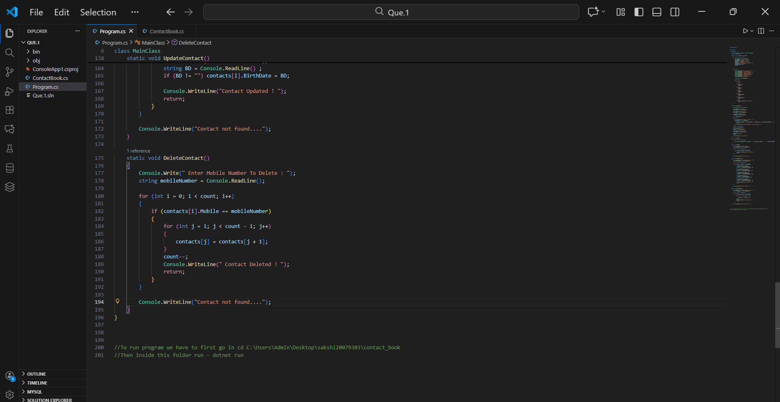
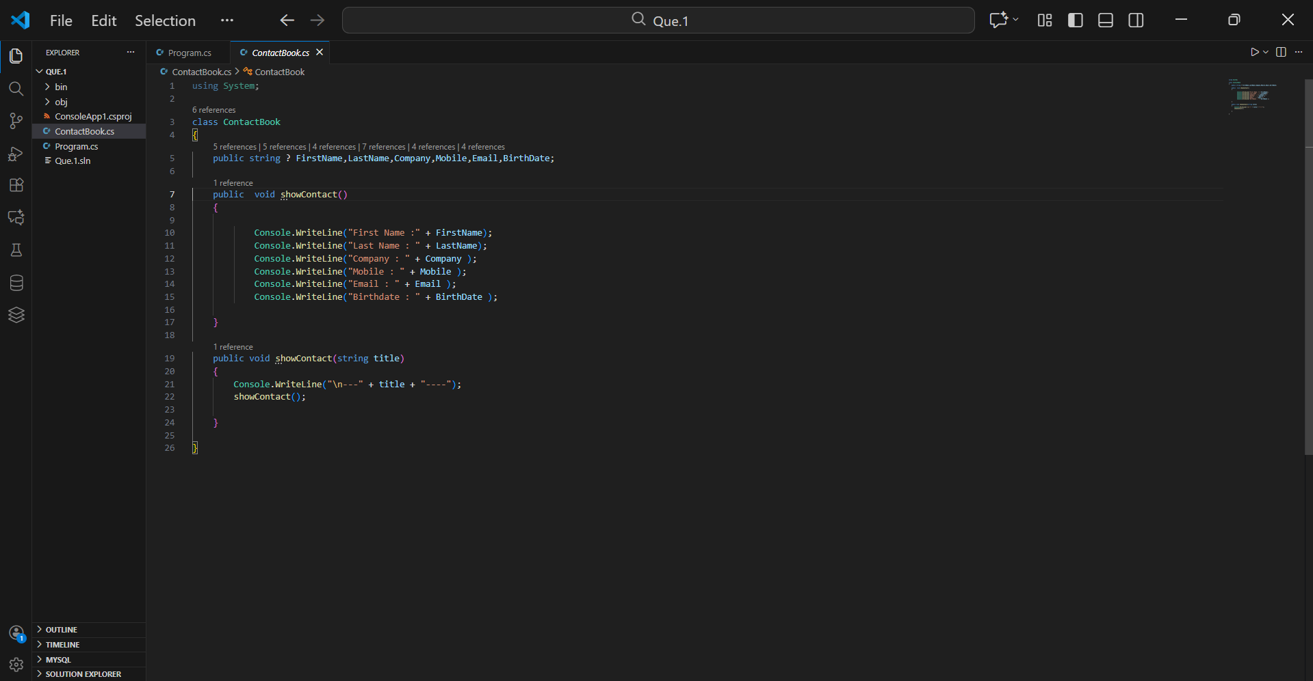
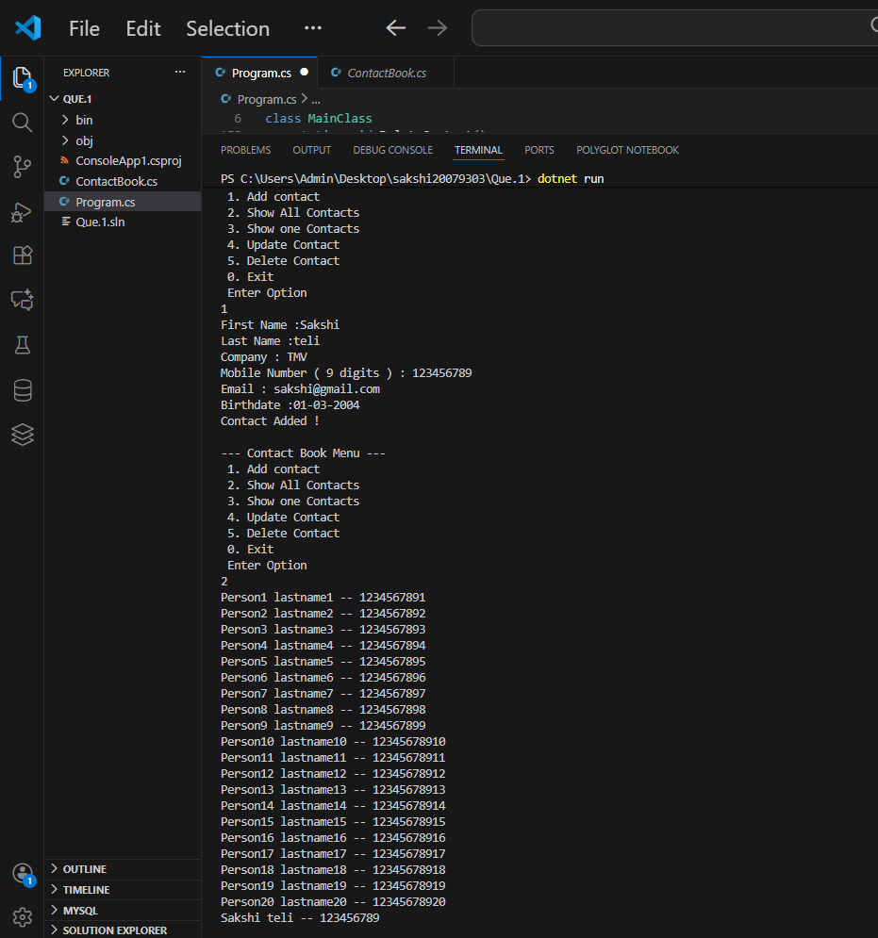

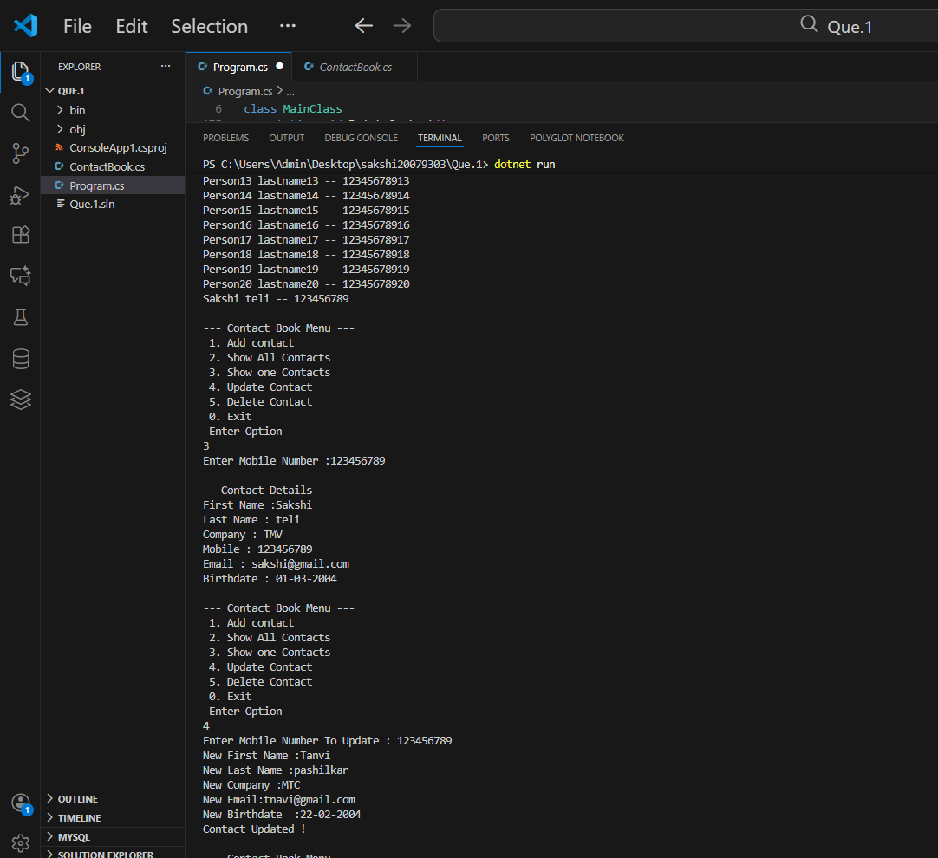
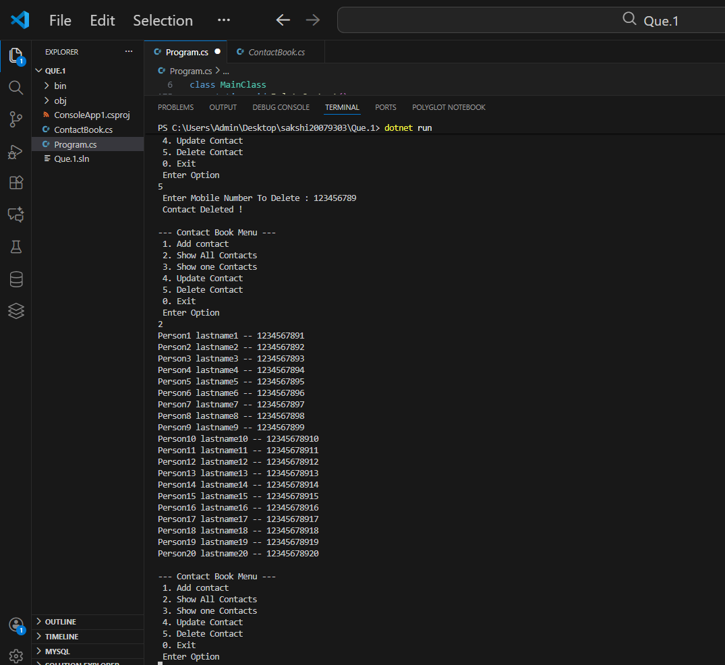

2.2 Question 2 – File Extension System
I made a C# console program that shows details about various file extensions in response to this question. For this project , I used two files :
- Program.cs – Contains the menu and all functions
- FileExtension.cs – Contains the FileExtension class

The FileExtension class stores two things :

a)the file extension(like .mp4,.pdf)
b)its description (like video file, document , audio file)

I used an array of FileExtension objects in the main program and added 20 default extensions using the AddDefaultExtension() method. I created a menu that lets the user show all extensions, search for one, add new ones, update a description, or delete an extension. If the user types an extension without a dot, the program adds it automatically. If an extension is not found, the program shows a “not found” message. I used basic OOP ideas like classes, objects, and methods, and I tested the program using dotnet run.

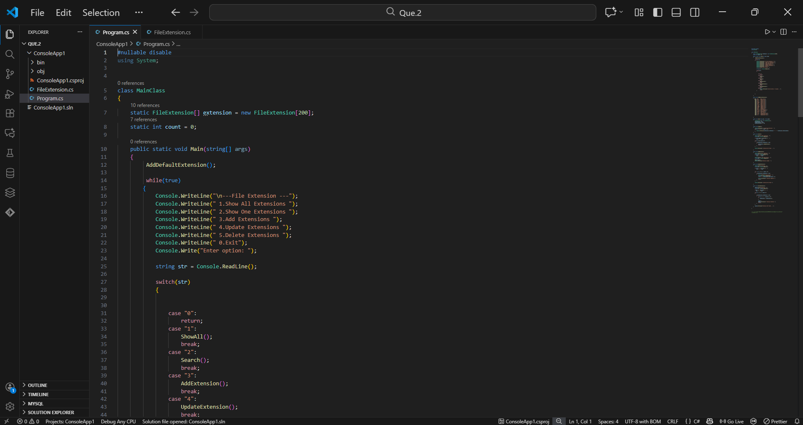

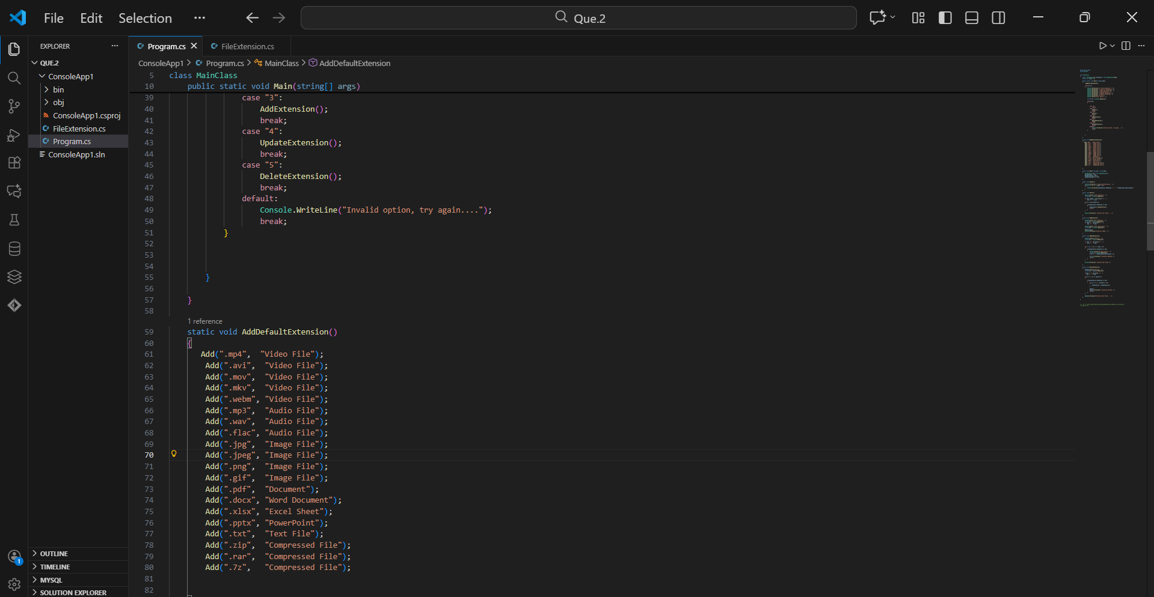

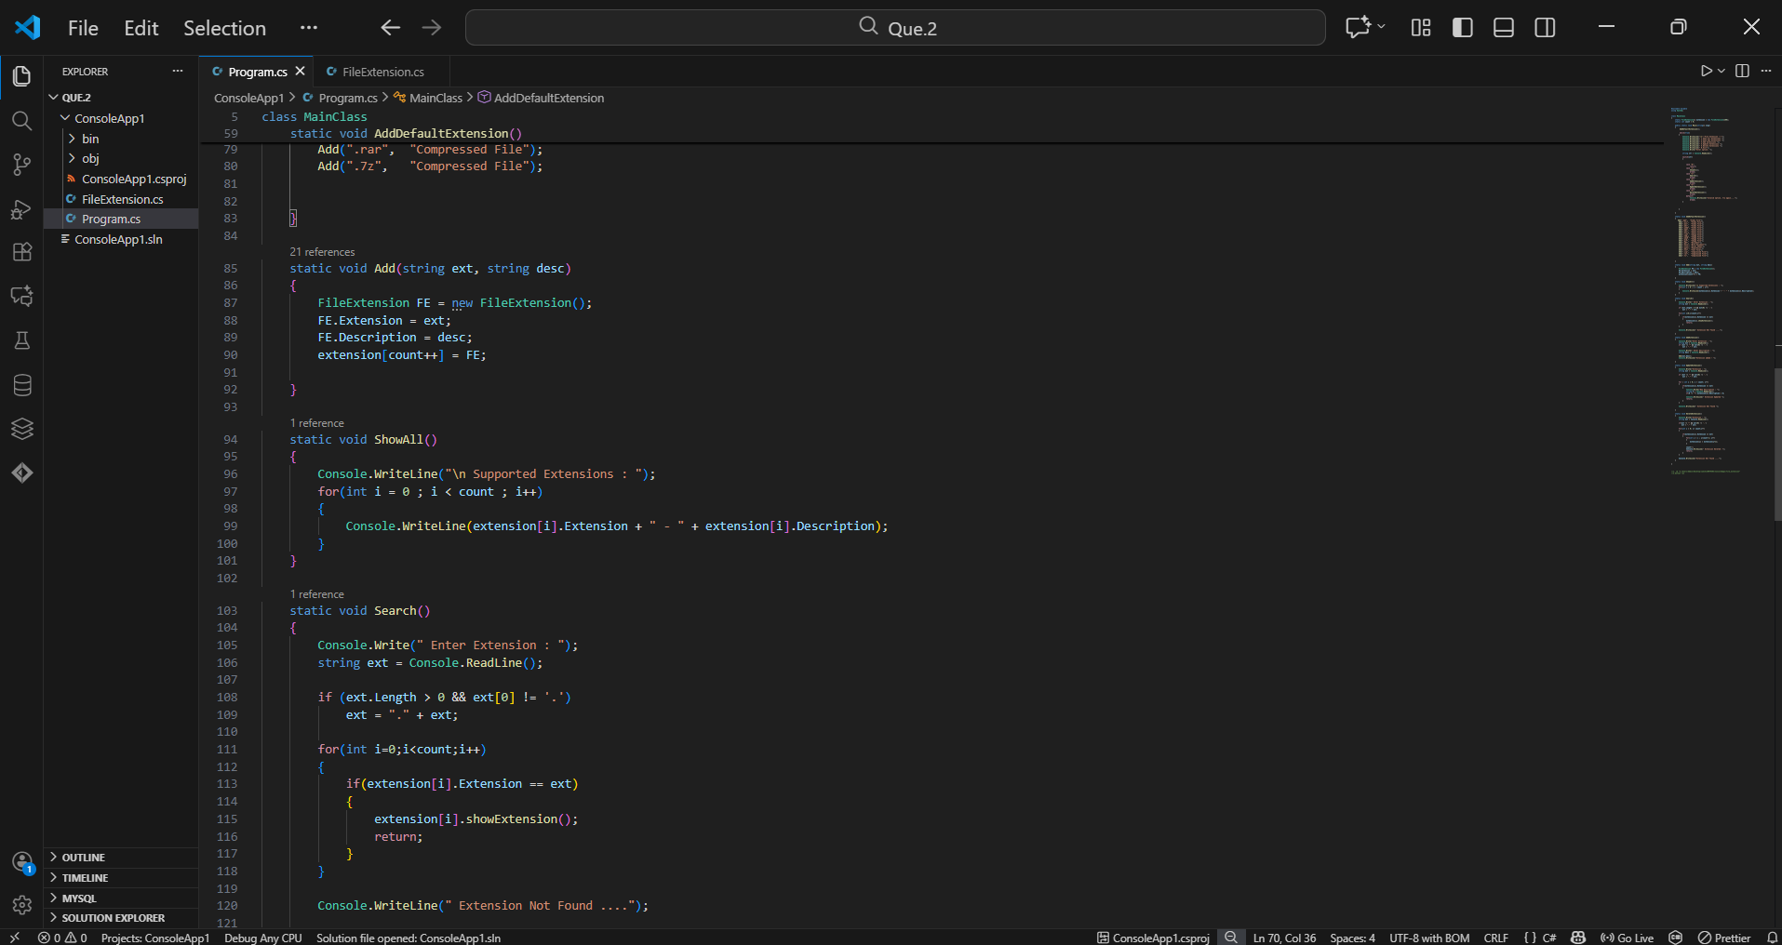

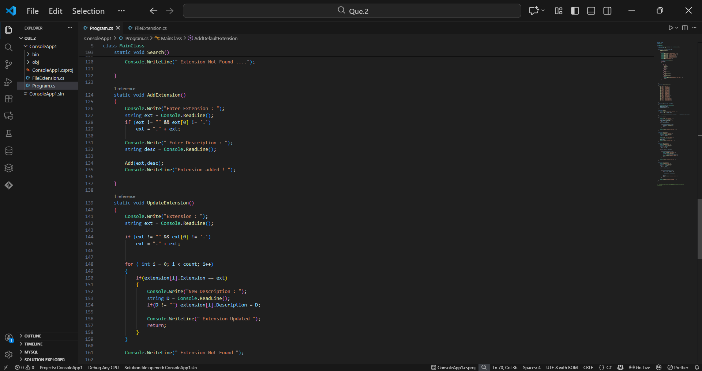

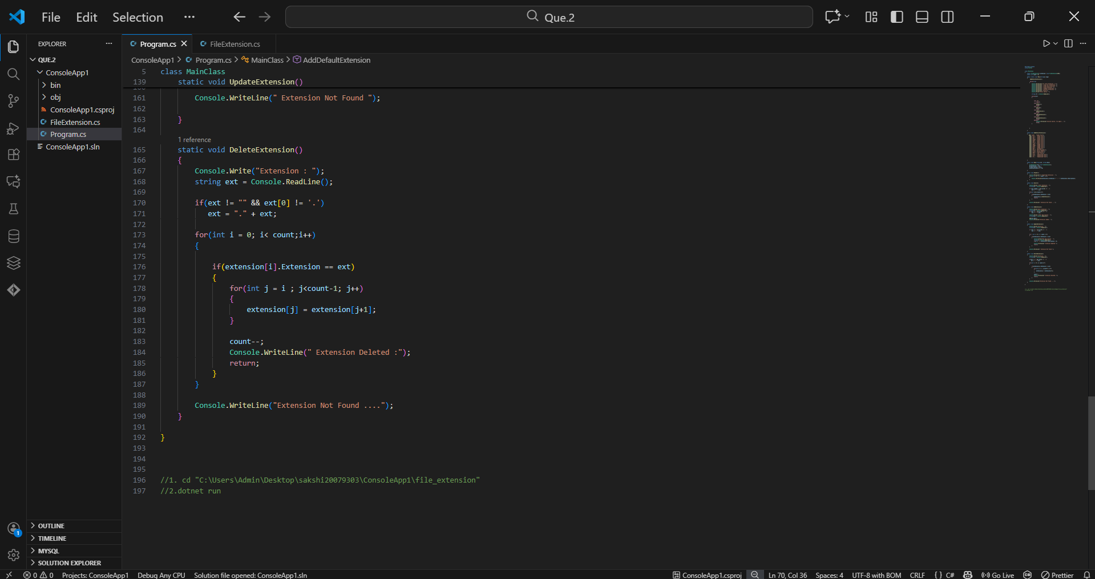

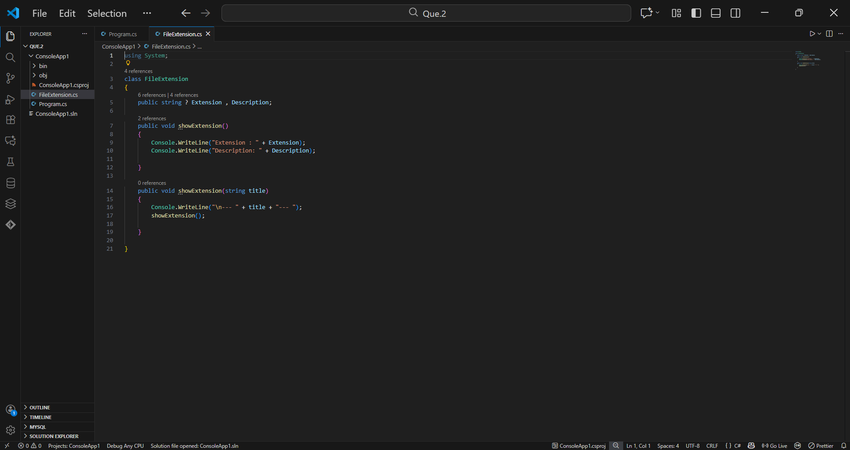

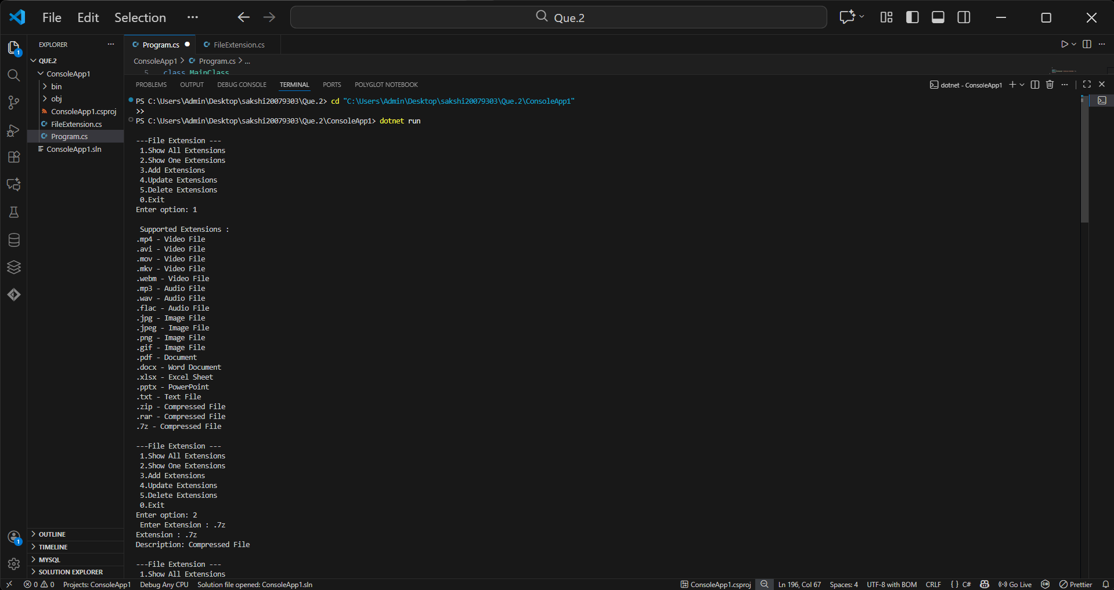

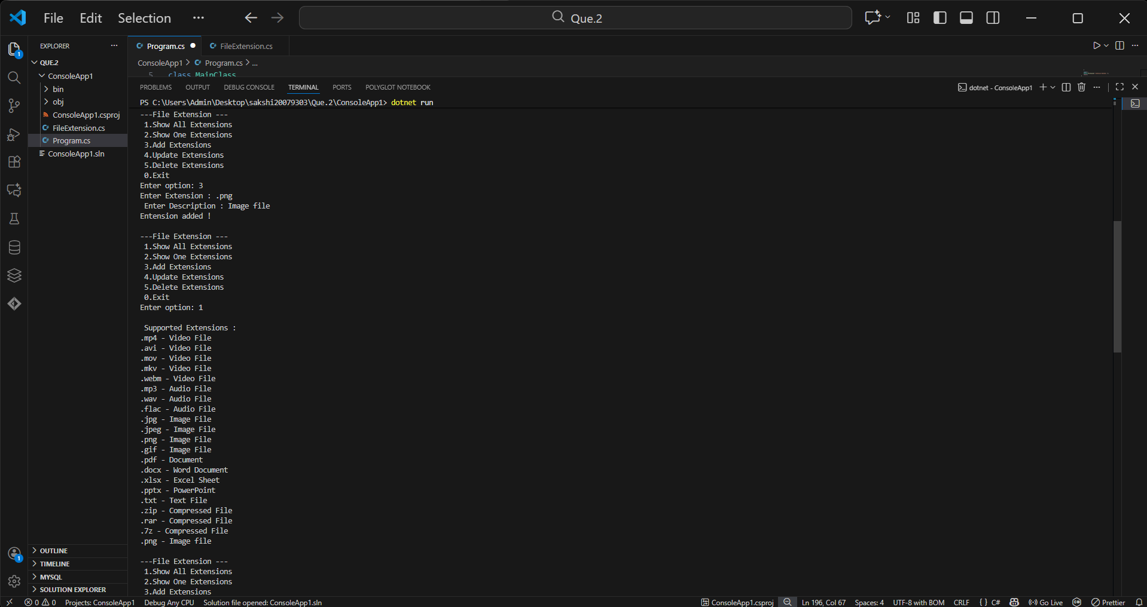

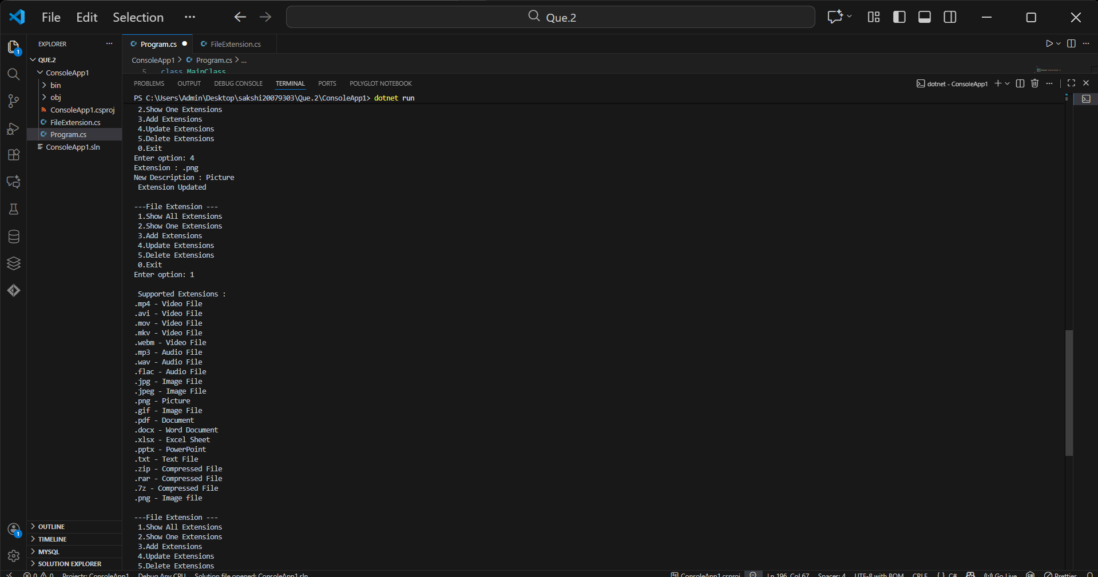

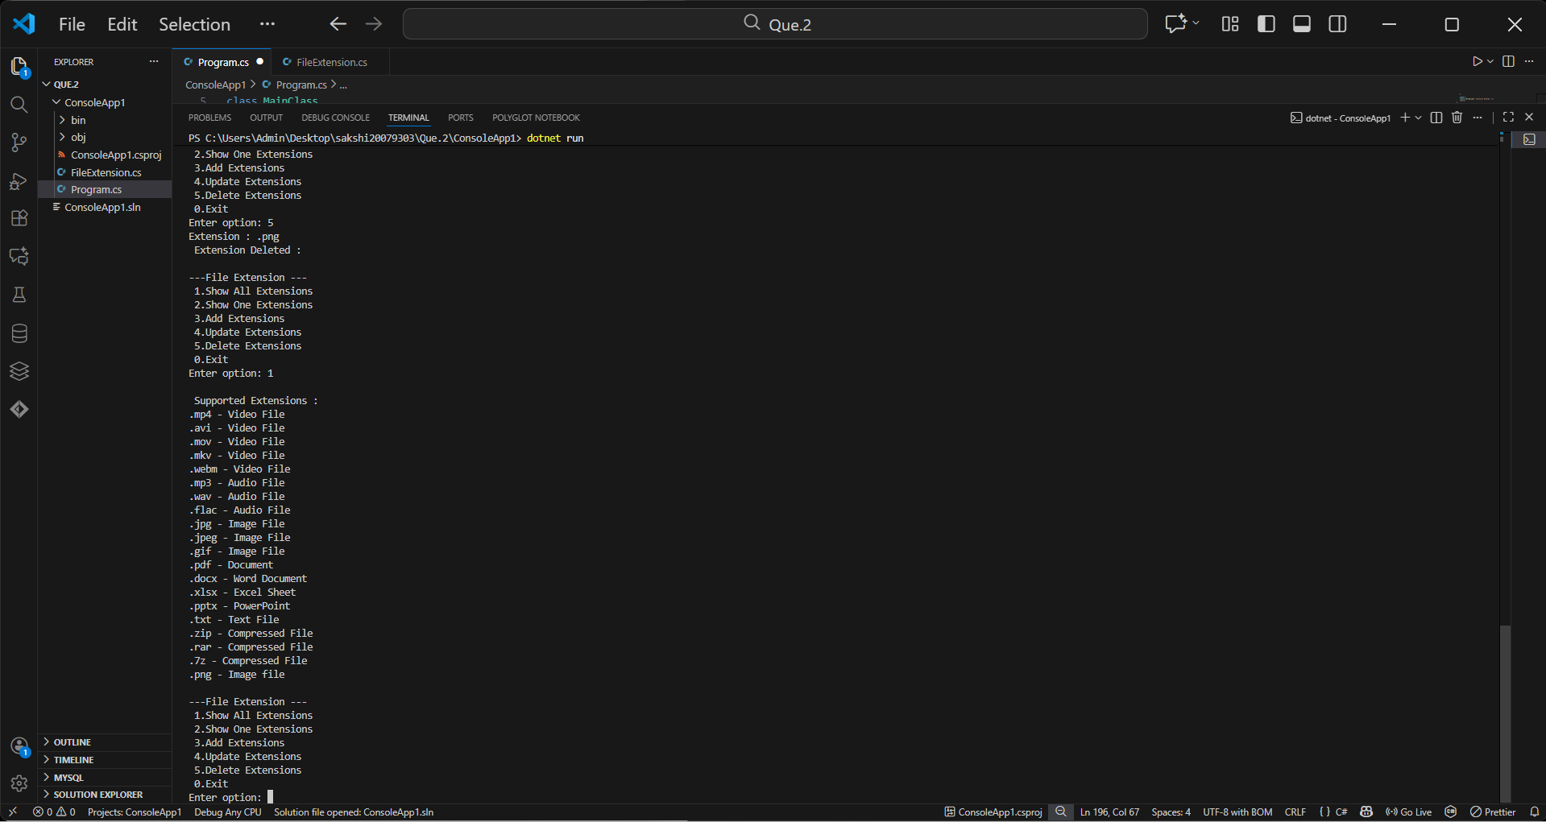

Part II: Python Programming
3.1 Question 3 – Client–Server Application
Using Python Sockets, I developed a server program that waits for a client . I developed a client program that sends information about student admission to the server . I created a database file with all of the student data using SQLite .After receiving the data , the server generates a unique application number and saves it . The application number is returned to the client by the server . The server sends the application number back to the client . The client shows the application number to the user . Databases , TCP communication, and simple string handling are used in this work.
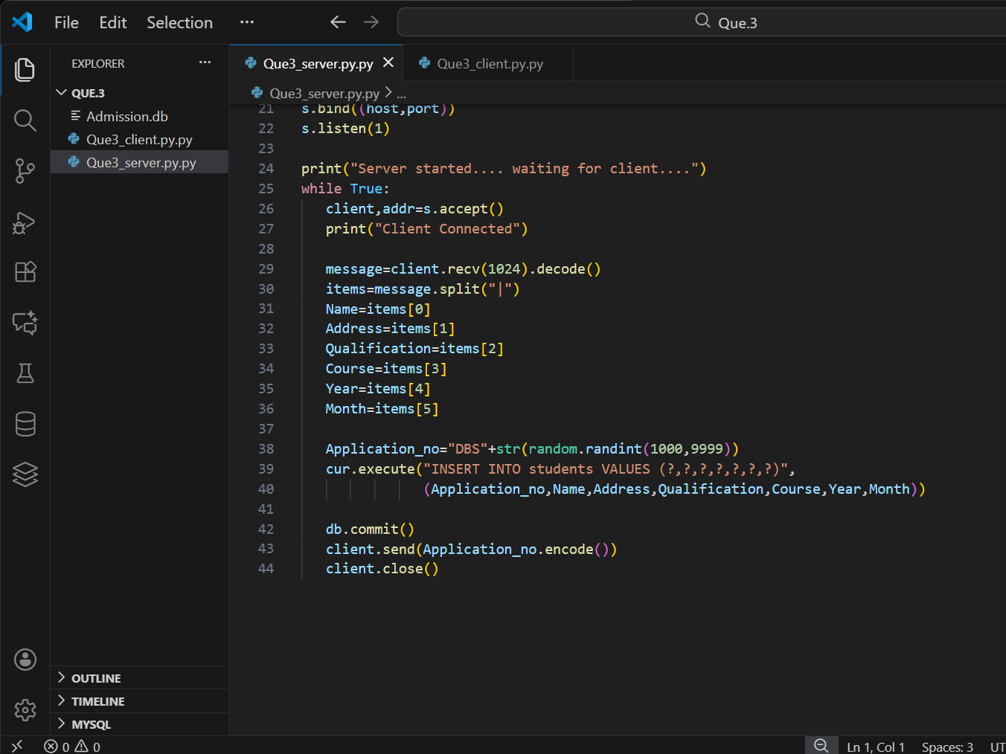

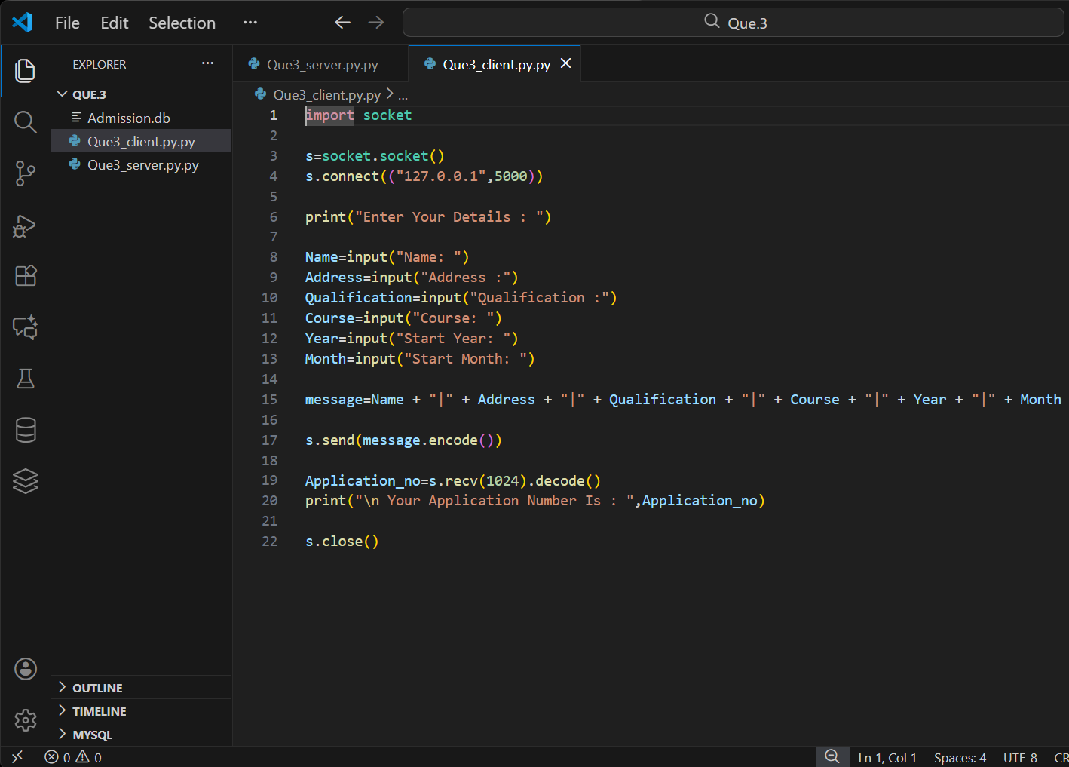

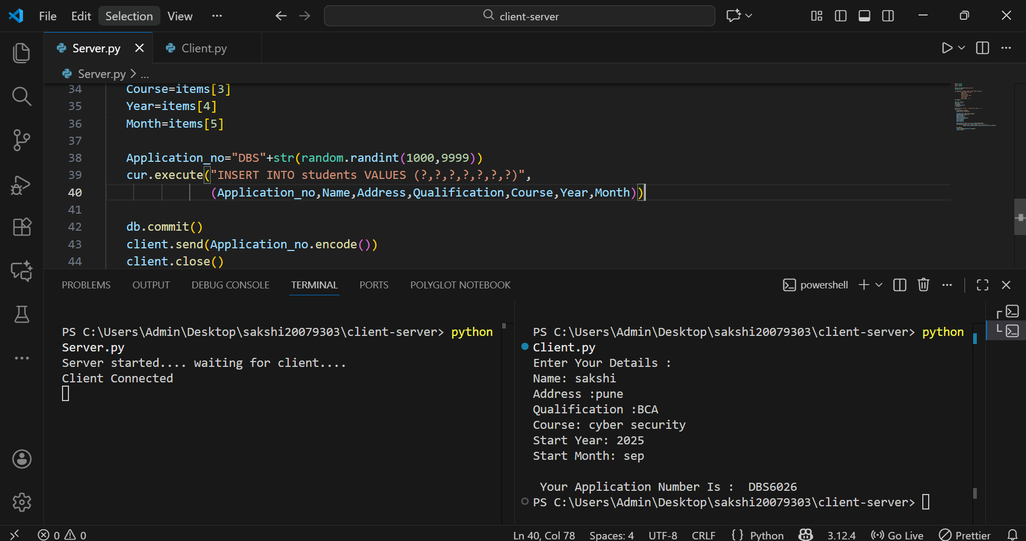

3.2 Question 4 – Web Scraping and CSV Handling

4.Conclusion
I was able to practice C# and Python by creating basic applications for this assignment. I learned how to use OOP , data management , database administration , and client-server communication.
5. Reference
- Microsoft. (2024) C# Documentation: Classes and Objects. Available at: https://learn.microsoft.com/en-us/dotnet/csharp/fundamentals/object-oriented/classes
- Python Software Foundation. (2024) socket — Low-level networking interface. Available at: https://docs.python.org/3/library/socket.html
- SQLite. (2024) SQLite Language Documentation. Available at: https://www.sqlite.org/lang.html

